Establishing the Strathclyde Early Diagnostics Consortium
Friday 21st May 2021
10:00 – 13:00
Welcome – Dr Helen Mulvana
10:00 – 10:05
Clinical perspective – the drive for early diagnosis
Prof Laura Machesky, Director of the Institute of Cancer Services, The Beatson
10:05 – 10:20
Prof Susan Moug, General Surgeon, Royal Alexandra Hospital Paisley & Golden Jubilee Hospital
10:20 – 10:35
Academic expertise at the University of Strathclyde
Imaging Technologies and blood flow analysis
Dr Asimina Kazakidi, Dr Helen Mulvana, Dr Teti Stratoudaki
10:35 – 10:50
Bionanotechnology and Analytical Chemistry
Dr Lynn Dennany, Prof Karen Faulds, Prof Duncan Graham, Dr Clare Hoskins
10:50 – 11:05
A systems-based approach to early diagnostics and biomarker development
Dr Nik Rattray, Dr Zahra Rattray
11:05 – 11:20
Establishing a 4D pre-symptomatic non-invasive diagnostic platform
Dr Yi-Chieh Chen
11:20 – 11:25
Break 11:25 – 10:35
Commercial interest in early diagnosis
OhMedics: Healthcare on the go
Prof Patricia Connolly, OhMedics
11:35 – 11:50
iCaird: The Industrial Centre for Artificial Intelligence Research in Digital Diagnostics
Dr Alexander Weir, Canon Medical & iCaird
11:50 – 12:05
Funding available
Alexis Webb, CRUK
12:05 – 12:20
Michael Onoja, EPSRC
12:20– 12:35
Discussion
12:35 – 12:55
Next steps and close
12:55
Speakers
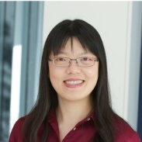
Dr Yi-Chieh Chen
Spectroscopy has been the centre of my research interest and career. My aim is to apply advance spectroscopic techniques to investigate nanostructure materials for optical sensing applications. I am especially familiar with Raman and surface-enhanced Raman spectroscopy, light scattering spectroscopy and surface plasmon spectroscopy. My current research project focuses on the development of robust optical measurement-interpretation platform by utilising UV-vis-NIR spectroscopy in the fields of process analysis and biomedical diagnostics. I am also interested in applying the concept to other spectroscopic techniques to overcome challenges in instrumentation and analysis of measurements. I am currently leading the Measurement and Analytics Team in Strathclyde. My long term goal is to lead integration of analytical science to provide solutions for challenges faced in scientific and industrial communities.
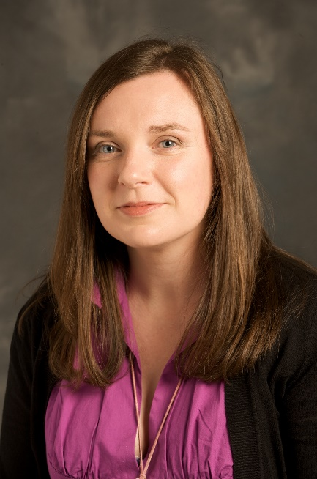
Dr Lynn Dennany
Lynn Dennany work within three core areas: (1) novel electrochemiluminescence (ECL) materials; (2) development of robust surface attachment strategies for enhanced ECL sensitivities and multiplexed detection; (3) devising of novel advanced methodologies for ultrasensitive disease biomarker detection, with the aim of making an impact on improving clinical practice. In particular, the detection of oxidative stress leading to mutagenesis, neurological diseases and aging and the early detection of biomarkers for disease detection through the exploitation of electrochemical detection strategies. This focuses on targeting biomarkers through an understanding of their electrochemical properties or their interaction with electrochemically active sensing materials.
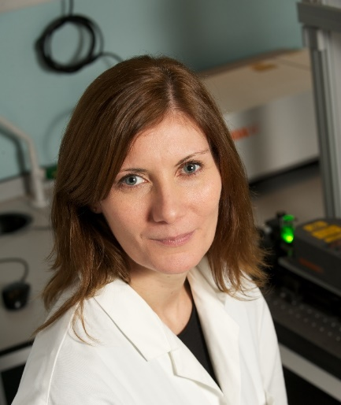
Dr Karen Faulds
My research involves developing Raman techniques and surface enhanced Raman scattering (SERS) for bioanalytical applications. Using Raman and stimulated Raman scattering (SRS) we can image changes in biochemistry i.e. lipid, DNA, protein content in cells and tissue in response to different stimuli as well as monitor changes in pH and enzyme activity in situ. Using nanoparticles combined with SERS, we develop bionanosensors for the specific detection of biomarkers related to disease. The main advantages of SERS is the sensitivity and the multiplexing capabilities due to the vibrational fingerprint obtained. We are using this approach for the detection of multiple DNA sequences related to disease, multiple biomarkers that indicate the onset of sepsis, drug induces liver damage and indicators of cardiovascular disease, for the detection and understanding of cancer and drug treatments and for the sensitive detection of whole bacteria in both the healthcare setting and the food industry. These approaches are being developed with a view to point of care detection. We are also developing the approach of surface enhanced spatially offset Raman (SESORS) for the detection of disease changes at depth with a view to carrying out measurements at depth, inside the body, for the identification of changes related to cancer and bacterial infection.
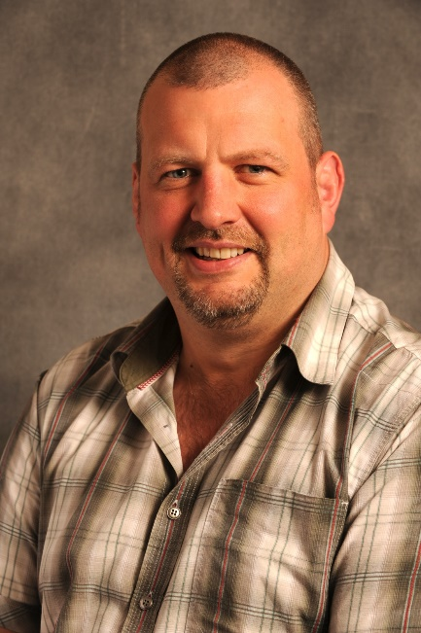
Prof Duncan Graham
Duncan Graham FRSE is holds the rank of Distinguished Professor and is the Head of the Department for Pure & Applied Chemistry at the University of Strathclyde. He started his research career with a PhD in Bioorganic Chemistry studying with Professor Tom Brown at the University of Edinburgh. He then moved to the University of Strathclyde where he became interested in the use of Surface Enhanced Raman Scattering (SERS) for use in biomolecular analysis aimed at improving healthcare. His research sits at the interface between Chemistry, Biology and Physics with a very strong push into the biomedical and clinical research sectors. He has developed specific nanoparticle based assays involving SERS for the detection of DNA relating to fungal infections which was translated into a CE marked product and used in hospitals in Europe. He is interested in creating new assays for biological targets (in vitro and in vivo) in response to clinical challenges and has funding from the EPSRC and MRC. A new avenue of research is using stimulated Raman scattering (SRS) in combination with molecular probes to reveal new molecular changes in cells and tissue. As such, his research interests span a range of different areas including bioanalysis, biomedical applications and new tools for biological research with a strong focus and grounding within chemistry and more specifically spectroscopy and nanoscience. He is the Vice Chair of the CRUK and EPSRC Multidisciplinary Expert Review Panel with the aim of bringing more physical sciences into cancer research and serves on CRUK’s Discovery Research Committee. He has published over 250 original research articles, trained over 70 PhD students and supervised over 30 research assistants.
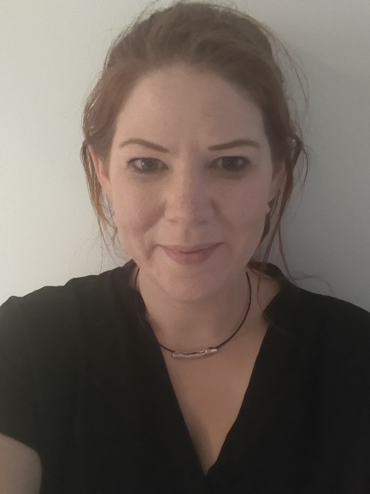
Dr Clare Hoskins
I work on the development of nanoparticle based platforms which can be used in precision medicine as therapeutic entities, in diagnostics or in theranostics (combined therapy and diagnostics). The range of nanoparticle platforms I work on depends on the clinical problem, and these could be polymeric, metallic or hybrid based systems. They can be designed for imaging or to be reactive to stimulus such as temperature, light or pH. They can be targeted to specific areas of interest which can allow for early detection or delivery of active pharmaceutical ingredients.
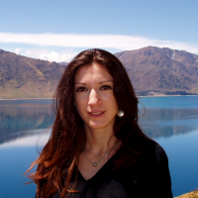
Dr Asimina Kazakidi
Dr Asimina Kazakidi is a Senior Lecturer in Biofluids Mechanics at the University of Strathclyde, where she initially joined as Lecturer in 2016. Prior to that, Asimina was a Research Fellow at the Foundation for Research & Technology – Hellas (FORTH), in Greece, and Research Associate at the National Heart and Lung Institute, Imperial College London, within the cardiovascular science research theme funded by the British Heart Foundation (BHF). She obtained her Ph.D. in Biofluid Dynamics from the Department of Aeronautics at Imperial College London, where she also completed an MSc in ‘Engineering and Physical Science in Medicine’ at Department of Bioengineering. Asimina (Melina) has an extended experience in Computational Fluid Dynamics (CFD). Her work has focused on complex biofluid mechanics problems, utilising a range of CFD methods. She has a specialised knowledge in all aspects of numerical simulation technology processes and in the communication of complex results.
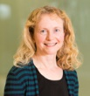
Prof Laura Machesky
Professor Laura Machesky heads a research group at the Beatson Institute for Cancer Research in Glasgow and is Director of the Institute of Cancer Sciences at the University of Glasgow. She’s interested in how tumour cells move and migrate, spreading the cancer to different areas of the body.
All cells contain a dynamic network of structural molecules that controls their shape and ability to move through their environment. Normally cell movement is a tightly controlled process but cancer cells can escape these regulations, invading surrounding tissues and spreading around the body before settling to develop new tumours.
Because cancers that have spread are much more difficult to treat, Professor Machesky is studying cells in the lab to better understand this process. In doing so, the group is identifying and developing molecules that block potential drug targets to stop tumours from spreading. Since there are no direct therapies against cancer spread, research such as Professor Machesky’s is desperately needed.
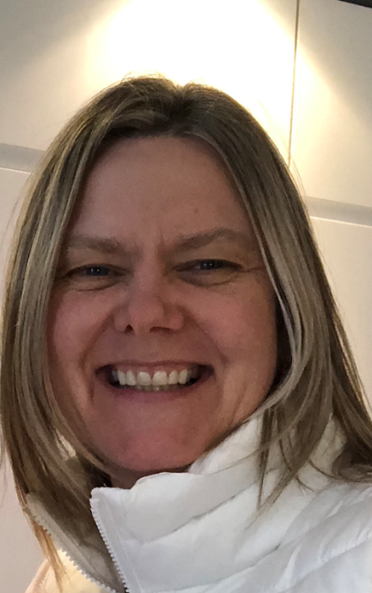
Ms Susan Moug
I am an academic colorectal and general surgeon in Royal Alexandra Hospital, Paisley and Golden Jubilee National Hospital. My research interests are linked by the common theme of improving surgical patient outcomes: frailty, older adult, lifestyle factors in colorectal cancer and contrast ultrasound for rectal cancer staging. I collaborate nationally and internationally within my own specialty, but also beyond, including geriatricians, bioengineers, and physicists. I currently hold a NRS Chief Scientist Office (CSO) Senior Research Fellowship and am one of two Surgical Specialty Leads for Colorectal (RCSEng). I have recently been appointed to Director of Research for ASGBI. I currently hold several grants (including CRUK) and am local and chief investigator for several UK led trials.
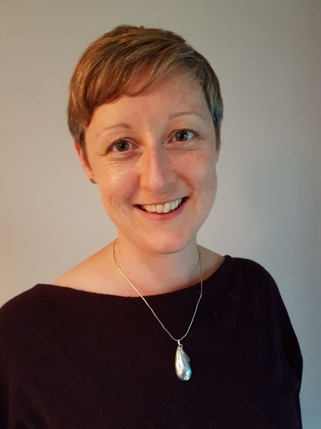
Dr Helen Mulvana
I am a Chancellor’s Fellow and Senior Lecturer in the Department of Biomedical Engineering. My research focus is the development of advanced diagnostic tools for the earlier diagnosis and targeted treatment of cancer. I work closely with clinicians to better understand clinical needs and with engineers and life scientists to develop solutions to these challenges.
Current funding supports research projects on the development of elasticity imaging using contrast-enhanced magneto-motive ultrasound for the early detection of colorectal cancer, a pilot clinical trial to establish effectiveness of contrast enhanced ultrasound to detect sentinel lymph nodes in rectal cancer, development of physiological flow phantoms to investigate factors capable of influencing ultrasound and microbubble mediated drug delivery, delivery of siRNA using ultrasound and microbubbles to treat hypertension in a mouse model and investigation of low frequency ultrasound to stimulate bone repair. I also have expertise in non-linear acoustics, contrast imaging, microbubbles, medical device design and fabrication, therapeutic ultrasound and elastography.
I am an elected member of the Royal Society of Edinburgh Young Academy Scotland, Associate Editor-in-Chief for IEEE Transactions in Ultrasonics Ferroelectrics and Frequency Control (TUFFC), Publicity Chair for IEEE UFFC Society, IEEE International Ultrasonics Symposium Technical Program Committee member and track co-lead in 2021. I founded and chair the Scottish Ultrasound Group to promote partnership with clinicians, academics and industry and I am a Chartered Engineer (IMechE).
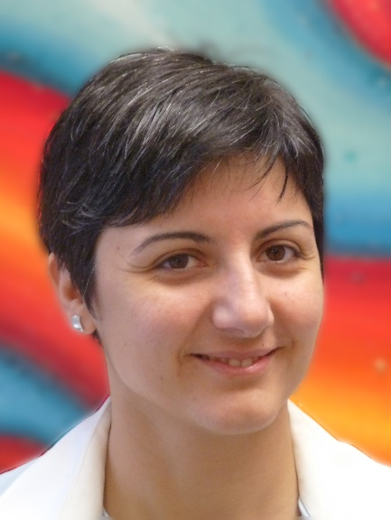
Dr Theodosia Stratoudaki
I am a Lecturer and a Strathclyde Chancellor’s Fellow at the Department of Electronic & Electrical Engineering, which I joined in 2017. I obtained my PhD in laser ultrasonics for carbon fibre composites from the Physics Department, at the University of Warwick. After a year of post-doctoral work at the Department of Chemistry of Cambridge University, I joined the Applied Optics Group of the University of Nottingham, before joining Strathclyde.
My main research is focused on sensing and imaging using light. I am currently in a collaboration with Bristol University in order to adapt a data collection method (Full Matrix Capture) developed for ultrasonic phased arrays, to laser based ultrasound and with Exeter University for work related to phononic crystals.
My research interests include: remote ultrasonic sensing/imaging using optical methods, non-destructive testing, chemical sensing, in-line manufacturing process monitoring in extreme environments, optically excited sensors, laser induced ultrasonic phased arrays, laser ultrasonics in advanced materials.
Due to the industrial applications of my work I have an extensive record of industrial collaborations which include Rolls-Royce, Airbus and Serco. I am co-chair of the Equality, Diversity and Inclusion committee at the Electronic & Electrical Engineering Department, member of the committee of the Physical Acoustics group, of the Institute of Physics and a member of the IEEE.
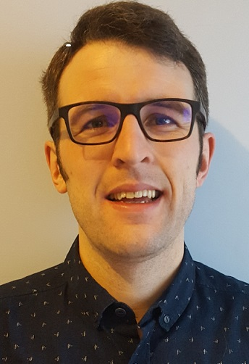
Dr Nik Rattray
Nik Rattray’s principal research interests lie in investigating metabolic changes throughout human life course with a focus on the dynamics of energy metabolism alongside biomarker detection. His lab is currently developing a targeted research theme that incorporates frailty and ageing related clinical projects alongside novel analytical approaches that enable the targeting and quantification of pathways critical to biochemical energy production. His portfolio of clinical research has covered a broad range of concepts including: population level analysis of frailty metabolism, early diagnostic and theranostic biomarker detection, energy metabolism across the biological and metabolic basis of colon cancer. He currently leads on mass spectrometry based metabolomics within the Faculty of Science.
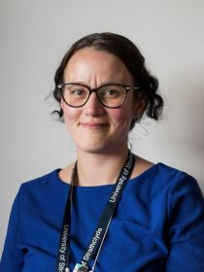
Dr Zahra Rattray
Zahra Rattray is a Chancellor’s research fellow and lecturer at the University of Strathclyde Institute of Pharmacy and Biomedical Sciences. Her interdisciplinary lab is interested in understanding the biological performance of drugs and drivers of cancer chemoresistance. Prior to joining Strathclyde, Zahra was a postdoctoral researcher at the Yale School of Medicine where she researched the impact of antinuclear autoantibodies in cellular phenotypic responses and explored their DNA targeting ability for designing new DNA damage repair agents.
Zahra’s prior roles include working as a senior formulation scientist at AstraZeneca Pharmaceuticals where she contributed to the oncology portfolio, and a postdoctoral associate at the University of Manchester in partnership with MedImmune where she developed new tools for probing protein aggregation.
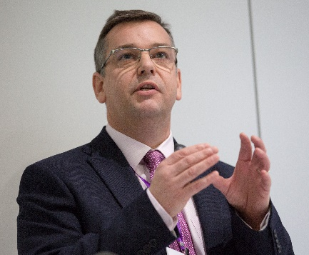
Dr Alexander Weir
Alexander Weir received the B.Eng. degree in Electronic and Electrical Engineering (first class honours) from Heriot-Watt University, Edinburgh, UK, in 1997, and completed an Engineering Doctorate with the Centre for Doctoral Training in Applied Photonics, School of Engineering and Physical Science at Heriot-Watt University in 2016. He has over twenty years of software development experience covering the full development life-cycle and has led several high-profile projects. He has worked for a range of companies, including British Aerospace, Cadence Design Systems and Thales Electronic Solutions, and has a diverse range of commercial experiences from defence and telecommunications, to short-range wireless protocol design for Bluetooth, DECT and UWB. In 2010 he branched into the field of healthcare technology. From 2010 to 2017 he developed and led medical technology innovation activities at the Medical Device Unit, Dept. Clinical Physics and Bioengineering, NHS Greater Glasgow and Clyde, where he was Technical Operations Manager. Within this role he was also a member of the European Commission working group on mHealth assessment guidelines from 2015 to 2016. In June 2017 he joined Toshiba Medical Visualisation Systems Europe, now Canon Medical Research Europe, where he is a Senior Technical Manager with responsibility for the AI Research group at their design centre in Edinburgh. As part of this role, he is also the Programme Manager for Canon led work packages and deliverables in the iCAIRD research programme. His interests include health informatics, the application of AI and machine learning in a broad range of applications in healthcare, signal and image processing, mHealth/eHealth, cloud-based services, and the Internet of Things.

